[HS12SP](http://www.digikey.ca/product-detail/en/amphenol-advanced-sensors/HS12SP/HS12SP-ND/4780894): Thermometric Relative Humidity Sensor

*Polymer based relative humidity sensor for humidity monitors and controllers, air conditioners, humidifiers and dehumidifiers, automatic ventilation.*

|  |  |  |
| --- | --- | --- |
| **Rated Working Voltage** | **Rated Power** | **Nominal Impedance** |
| *AC 1 V (50 Hz ~ 1 kHz)* | *0.3 mW* | *60 kΩ ± 30 kΩ* |

# *Typical Humidity Curve*

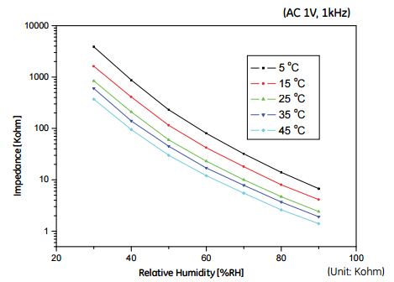

# *Signal Conditioning*

Need to design a circuit that will transform the impedance across the sensor into voltage levels that the ADC will recognize.

$$ADC_{input range}=0-5V$$

The relationship between *relative humidity* and *impedance* is logarithmic:

Taking the log of the dependent variable (Impedance), yields a relatively linearized relationship:

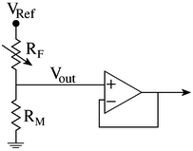The first part of the circuit will have to convert the sensor impedance to a voltage signal. This could be done with a voltage divider circuit. This circuit will amplify the entire voltage measured across the sensor.

$$V_{out}=\frac{1}{1+(\frac{R_{f}}{R_{m}})}$$

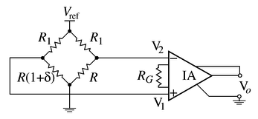Another option would be to measure only the change in the voltage (due to change in resistance) of the sensor. This could be done with a bridge and a differential amplifier (instrumentation amplifier).

$$V_{o}=A\frac{R}{R_{1}+R} V_{ref}\frac{δ}{1+(\frac{R}{R_{1}})(1+δ)}$$

An op-amp log amplifier diode circuit could be used to convert the voltage to a linear relationship which the ADC could interpret.

